**Polling App**

**What does our app do?**

Polling App as the name suggests helps a user to choose their favourite candidate among all.

**Objectives:**

* Admin can add a new election whenever [s]he wants.
* Admin can also add images or logo of the parties for voting.
* User can select their favourite candidate by Logging in their account.

**Why do we need this app?**

A Polling App can reduce the effort of manual voting. Moreover, a single person can vote by sitting at any corner of the world, thus saving both time and money.

**Technologies used:**

**Front-End:** HTML, CSS, JavaScript, Bootstrap, jQuery

**Back-End:** Flask, Flask-SQLAlchemy, Jinja

**Workflow:**

1. First admin needs to register every single user who is eligible for the voting.



1. After that admin can access the ‘admin’ features by going on ‘/admin’ route.[Where of course he needs to Login with his credentials.]

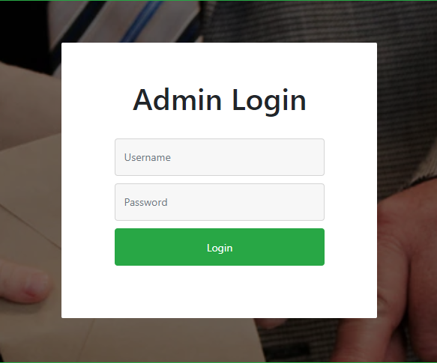

1. Then admin will create a new election by filling a simple form.

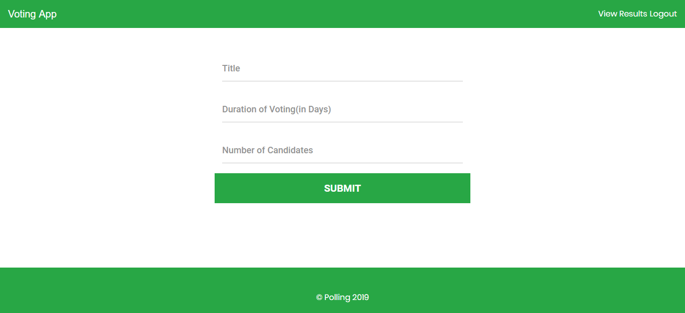

1. This form will ask to enter the title of the election, duration of the election, number of candidates participating in the elections etc.

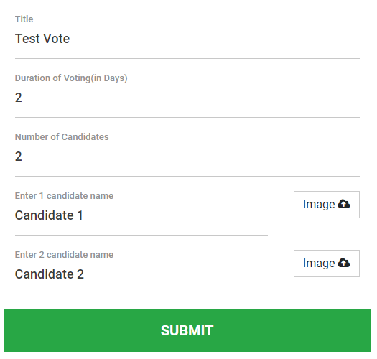

1. After submitting the form, a new election will be created.
2. To vote, a user first needs to Login using his credentials.

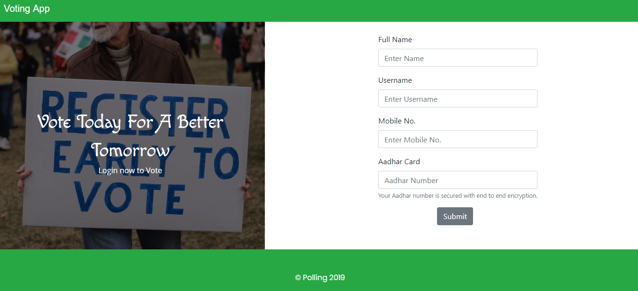

1. After that user can select any of the given candidates just by click on that candidates’ image.

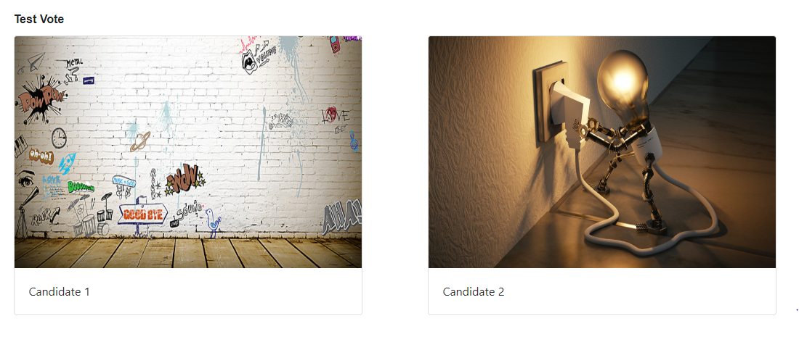

1. Admin can check real-time results of any election by clicking on the ‘View Results’ link.

